Scott Filline
ESP 541
19 March 2013

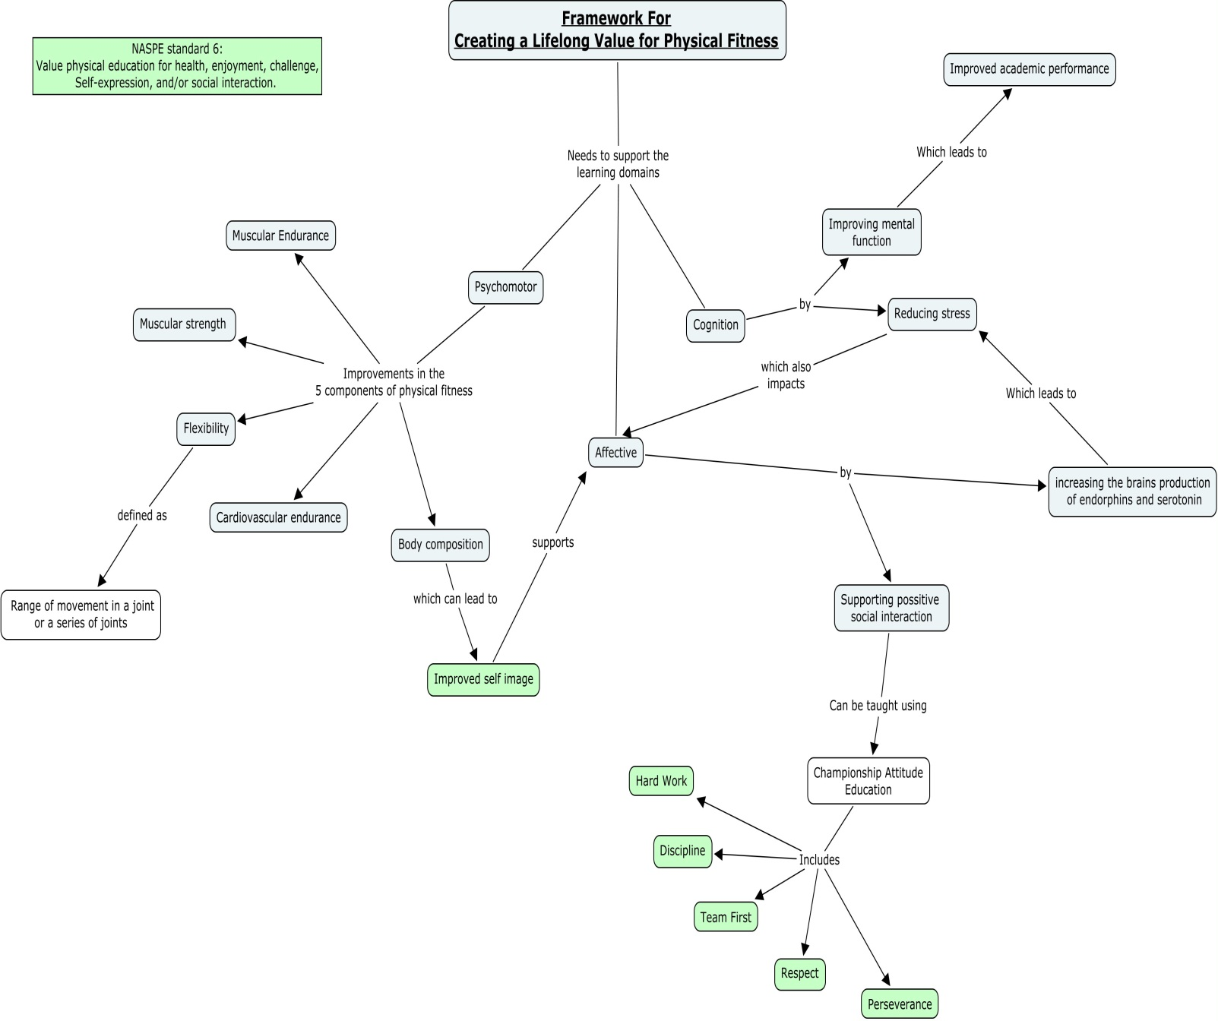

- Knowledge of Content Focus and Standards
My concept map was a little different than most everyone else’s. Instead of mapping out a specific goal or concept, I attempted to map out my own framework for creating effective, meaningful physical education lessons. There are no sport specific standards included for the unit I am planning for my upcoming lead teach experience (Lacrosse). As a physical education teacher who sees some groups of students for only 60 minutes a week, it is important for me to really focus my lessons on the most important concepts surrounding physical education. I believe that this concept is instilling a lifelong love of physical fitness and health in every one of my students.
Since there are no lacrosse specific physical education standards and a minimal amount of standards dealing with skill acquisition, all of my lessons this year have been centered on the six standards developed by the National Association for Sport and Physical Education, or, NASPE. These standards are extremely broad but they can be dissected in a number of ways that can apply to all grade and ability levels. When thinking about the skills involved with lacrosse, I utilize standard number two (Demonstrates understanding of movement concepts, principles, strategies, and tactics as they apply to the learning and performance of physical activities). However, the focus of my concept map is on standard number six (Values physical activity for health, enjoyment, challenge, self-expression, and/or social interaction). I believe that this standard hits on all of the major overarching concepts of physical education; therefore, it is the focus of my concept map.
It is always challenging to separate the sports we play in physical education class and the lifelong skills I am trying to teach. The sport education model of physical education does not teach sports for the sake of sport, it teaches children different physical skills while encouraging positive social interaction through gameplay. In the case of this lacrosse unit, I am teaching the unique skill of catching and throwing using an implement and about the concept of the transfer of motion and trajectory. On top of this, I am giving my students the chance to participate in a rare, interesting, and team centered sport that my students may not otherwise get a chance to play.
- Knowledge of Students relative to the Content
I believe that teaching a love for physical fitness is mostly about catering to the affective learning domain. In order for a person to take ownership for his or her fitness level, they must make a conscious decision to do so. This is related to understanding the positive feelings that are associated with taking care of ones’ self physically. This is exactly what I am trying to instill in my students. I am planning to administer journal type assessments to my students in order to gauge their feelings of PE class and physical fitness in general. Once I am able to get a clearer picture of how my students are feeling, I will be more able to give them what they need in order to succeed.
I believe that another way to instill a love for physical fitness in my students’ lives is by introducing them to unique sports such as lacrosse. Success in a game like lacrosse weighs heavily upon the basic skill acquisition that is associated with the sport. In order for my students to feel any amount of success, it was important for students to grasp these skills. Since lacrosse is a game that many of my students were new to, I started with the very basics of the sport and built my unit from there. My skill progression went from scooping a ball, cradling a ball, cradling around obstacles, and, finally, throwing and catching using a lacrosse stick. These are the most important aspects of the game of lacrosse; therefore, this was my skill focus for my unit.
I tend to look at my entire curriculum and arrange it according to skill progression. In this case I started with football (throwing and catching) and then moved on to hockey (Striking and controlling a puck with an implement) and, finally, lacrosse (throwing, catching, and controlling a ball using an implement). Each unit I cover includes some sort of skill that will be used directly in units to follow. So far this year I have noticed that the vast majority of my students are able to at least perform each skill with some level of proficiency. I have not yet experienced a student who is truly unable to perform a task given in physical education class even after numerous attempts to redirect and coach the student. I hope that my approach to physical education planning has played some sort of role in my students’ success.
- Knowledge of Instruction and Assessment Relative to Content
One of the points that stood out to me the most through our course readings and module work was the idea that the traditional learning modalities that I was educated to differentiate for may not have an impact of true student learning. In the past I would keep my eyes peeled for students who I thought to be auditory learners or visual learners and so on and so forth. This has inspired me to dig deeper into my instruction and to try and find the teaching method that will bring forth true learning. As of right now I have found the most success in incorporating socially relevant materials and trying my best to relate content to my students’ other interests.
I also am looking forward to incorporating personal fitness journal entries into my lesson planning and assessments. I feel that all too often physical education teachers fall into the depths of mediocrity as they accept the falsity that all assessment in physical education is informal and observation based. It is true that a large portion of assessment is informal, but that does not mean that everything is. A journal entry is a great way to break this trend and give students a chance to express themselves in a stress free environment. I will encourage my students to really share what they are feeling based on the exercises we performed and the skills we are learning. Of course, there is the chance that I will receive some negative entries from students who do not care much for physical education, but even these entries will give me a better glimpse of each of my students’ personalities.
The following assessment is the assessment that I plan to give as an exit ticket after all the skills of lacrosse have been taught and the game has been played. I will use this assessment both as an observation tool and as a way to gauge my students’ feelings about learning lacrosse and how I could improve this unit the next time I teach it.

For Mr. Filline to fill out:
 | 1  3 or more errors.  This skill could use some work | 2  Skill was performed with minimal errors | 3  Skill was performed with no errors or redirection
Grip
Scoop
Cradle
Throw
Tips for Improvement:

- - - - - - - - - - - - - - - - - - - - - - - - - - - - - - - - - - - - - - - - - - - - - - - - - - - - - - - - - - - - - - - - - - - - - - - - - - - - - - - -
For you to tell me how you feel:
On a scale of 1 to 5, how would you rate your current level of fitness? ________
Why? ____________________________________________________________

What is your favorite feeling associated with exercise? _____________________
Why? _____________________________________________________________

If you could sum up you feeling about lacrosse in one sentence, what would that sentence be? ___________________________________________________________________
_______________________________________________________________

